**Report №1**

**Id:** 001

**Summary:** Broken link

**Environment:** Os: Windows 10/ Browser: Google Chrome

**Severity:** Major

**Priority:** High

**Screenshot:**

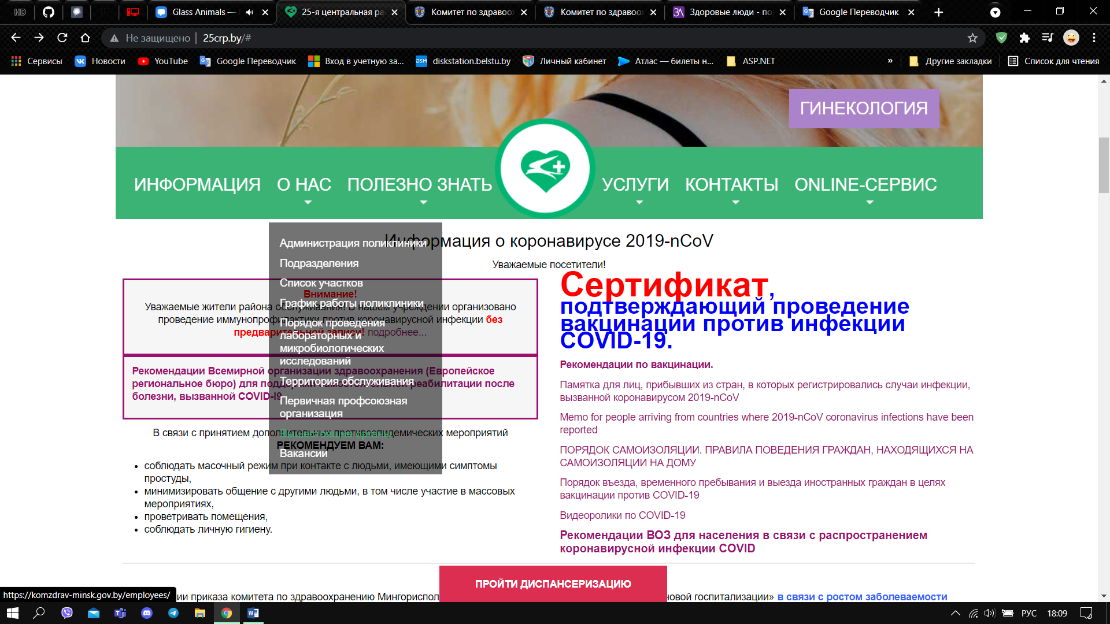

**Assignee:** Julia Aleksandrovna

**Steps to reproduce:**

1. Press the menu item named «О нас»
2. Press the menu item named «Вышестоящие органы» in the opened list

**Actual result:** Going to the 404-error page.

**Expected result:** Go to the page

**Notes:**

**Report №2**

**Id:** 002

**Summary:** Broken link

**Environment:** Os: Windows 10/ Browser: Google Chrome

**Severity:** Major

**Priority:** High

**Screenshot:**

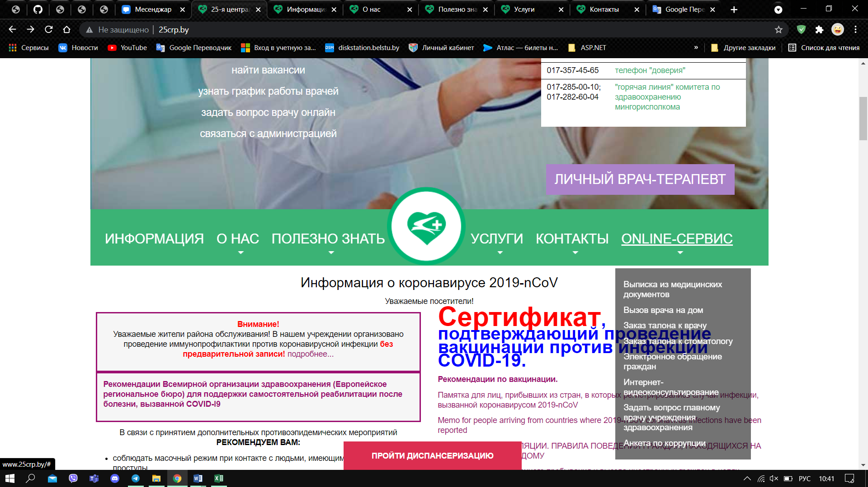

**Assignee:** Julia Aleksandrovna

**Steps to reproduce:**

1. Press the menu item named “ONLINE-СЕРВИС”

**Actual result:** Nothing happens

**Expected result:** Following a link

**Notes:**

**Report №3**

**Id:** 003

**Summary:** Broken link

**Environment:** Os: Windows 10/ Browser: Google Chrome

**Severity:** Major

**Priority:** High

**Screenshot:**

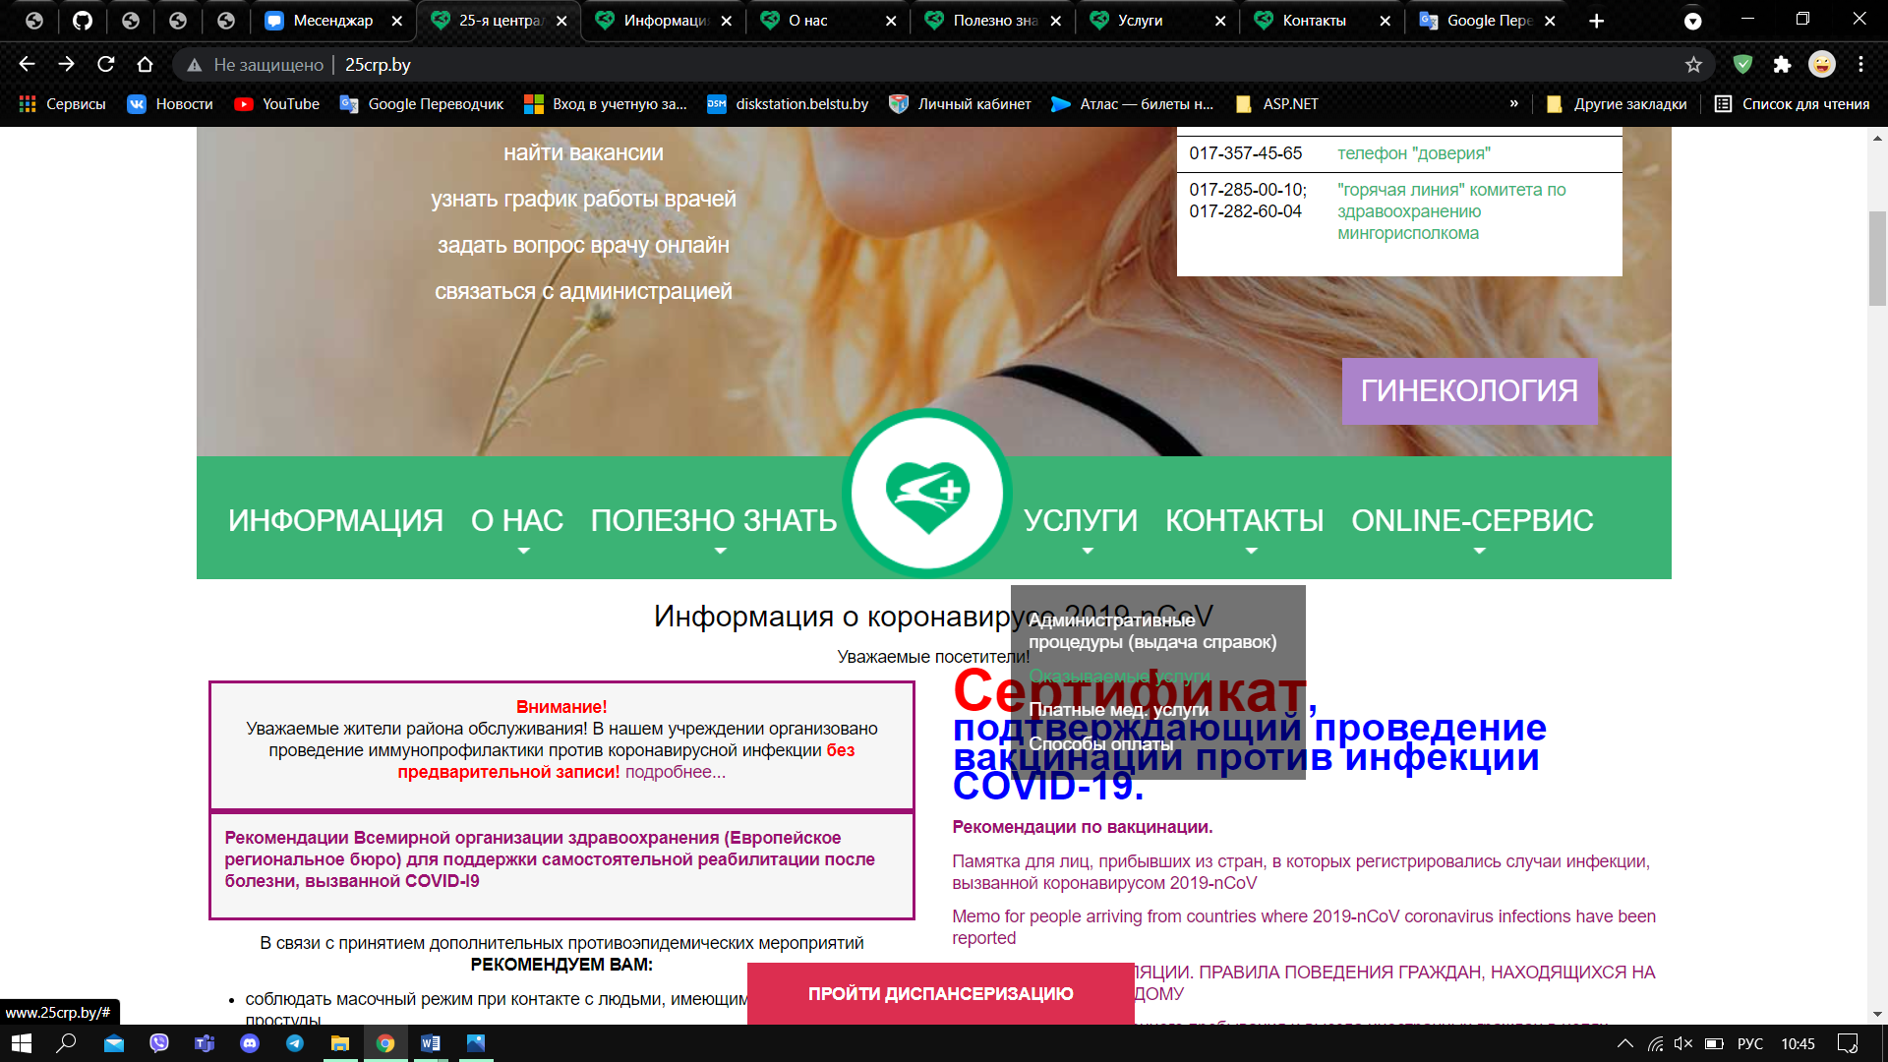

**Assignee:** Julia Aleksandrovna

**Steps to reproduce:**

1. Press the menu item named “Организуемые услуги”

**Actual result:** Nothing happens

**Expected result:** Following a link

**Notes:**

**Report №4**

**Id:** 004

**Summary:** Text overlays on search result

**Environment:** Os: Windows 10/ Browser: Google Chrome

**Severity:** Low

**Priority:** Low

**Screenshot:**

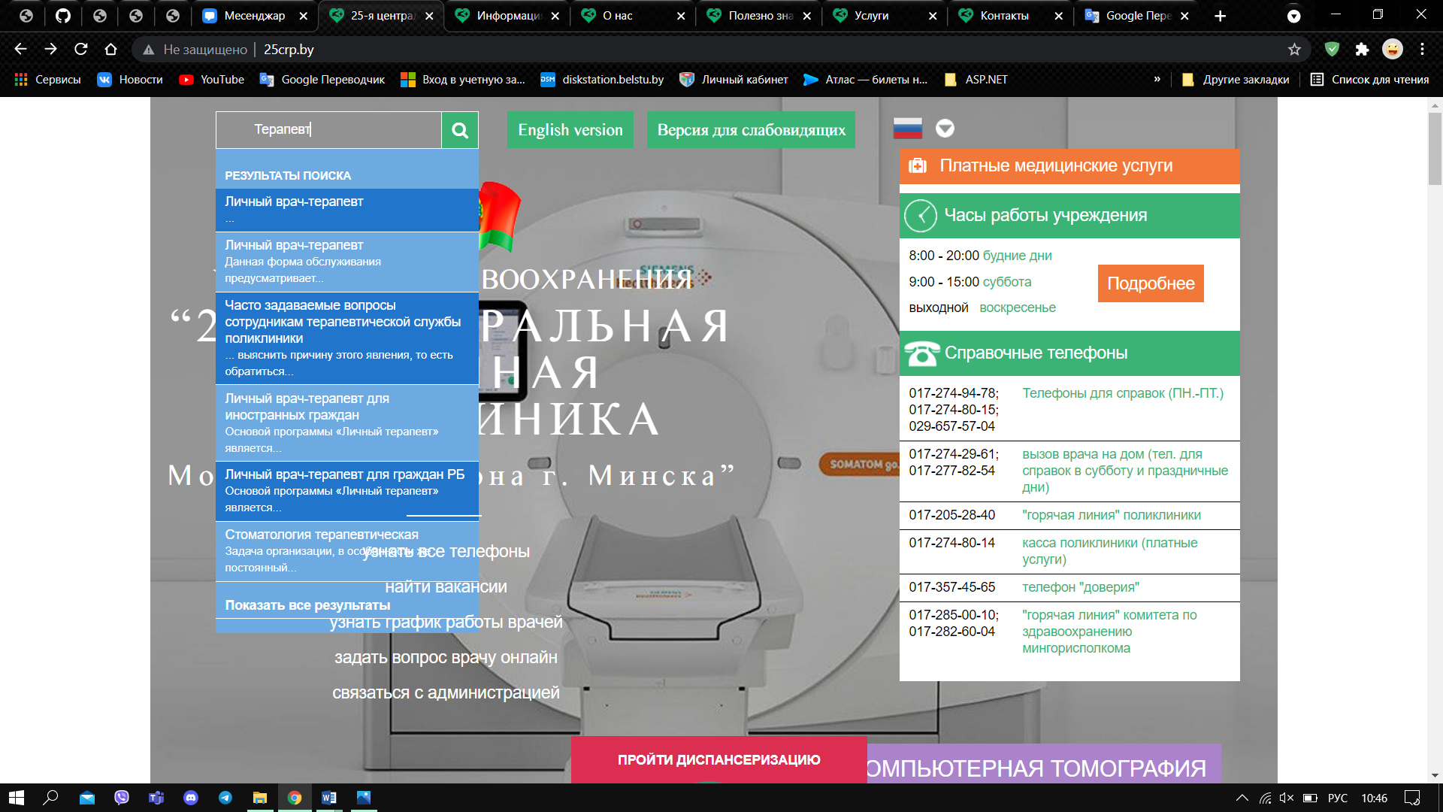

**Assignee:** Julia Aleksandrovna

**Steps to reproduce:**

1. Write something into the search box

**Actual result:** Text overlays on search result

**Expected result:** Text should be under search result

**Notes:**

**Report №5**

**Id:** 005

**Summary:** Search button on the main page doesn’t work

**Environment:** Os: Windows 10/ Browser: Google Chrome

**Severity:** Medium

**Priority:** High

**Screenshot:**

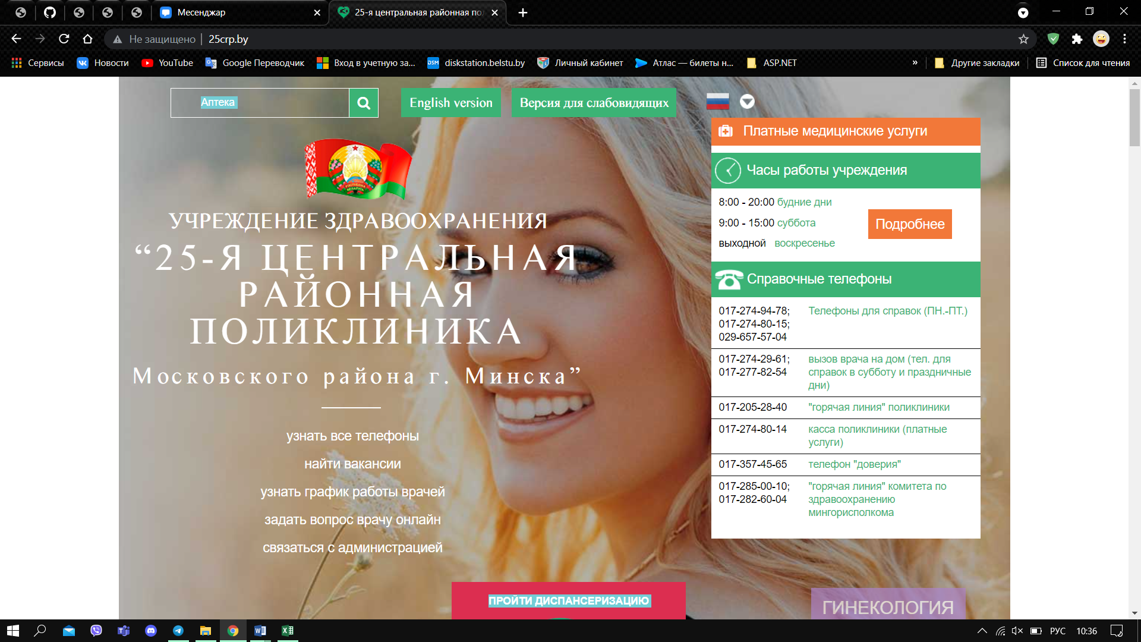

**Assignee:** Julia Aleksandrovna

**Steps to reproduce:**

1. Write whatever into search box
2. Press the search button

**Actual result:** Nothing happens

**Expected result:** Search process

**Notes:**

**Report №6**

**Id:** 006

**Summary:** The text is not translated into Belarusian

**Environment:** Os: Windows 10/ Browser: Google Chrome

**Severity:** Low

**Priority:** Low

**Screenshot:**

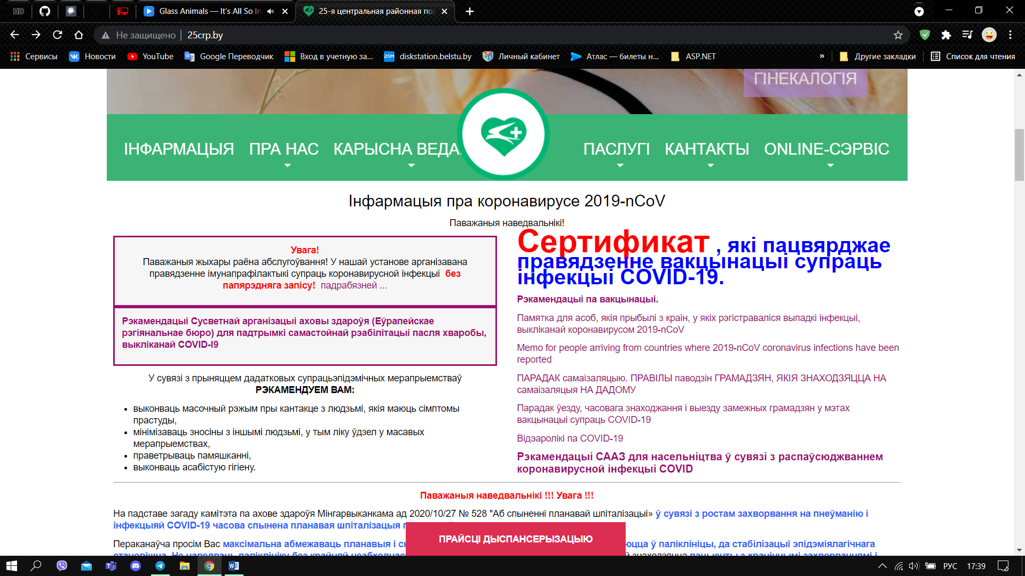

**Assignee:** Julia Aleksandrovna

**Steps to reproduce:**

1. Change language to Belarusian

**Actual result:** Some words don't get translated

**Expected result:** All words are translated

**Notes:**

**Report №7**

**Id:** 007

**Summary:** Broken link

**Environment:** Os: Windows 10/ Browser: Google Chrome

**Severity:** Major

**Priority:** High

**Screenshot:**

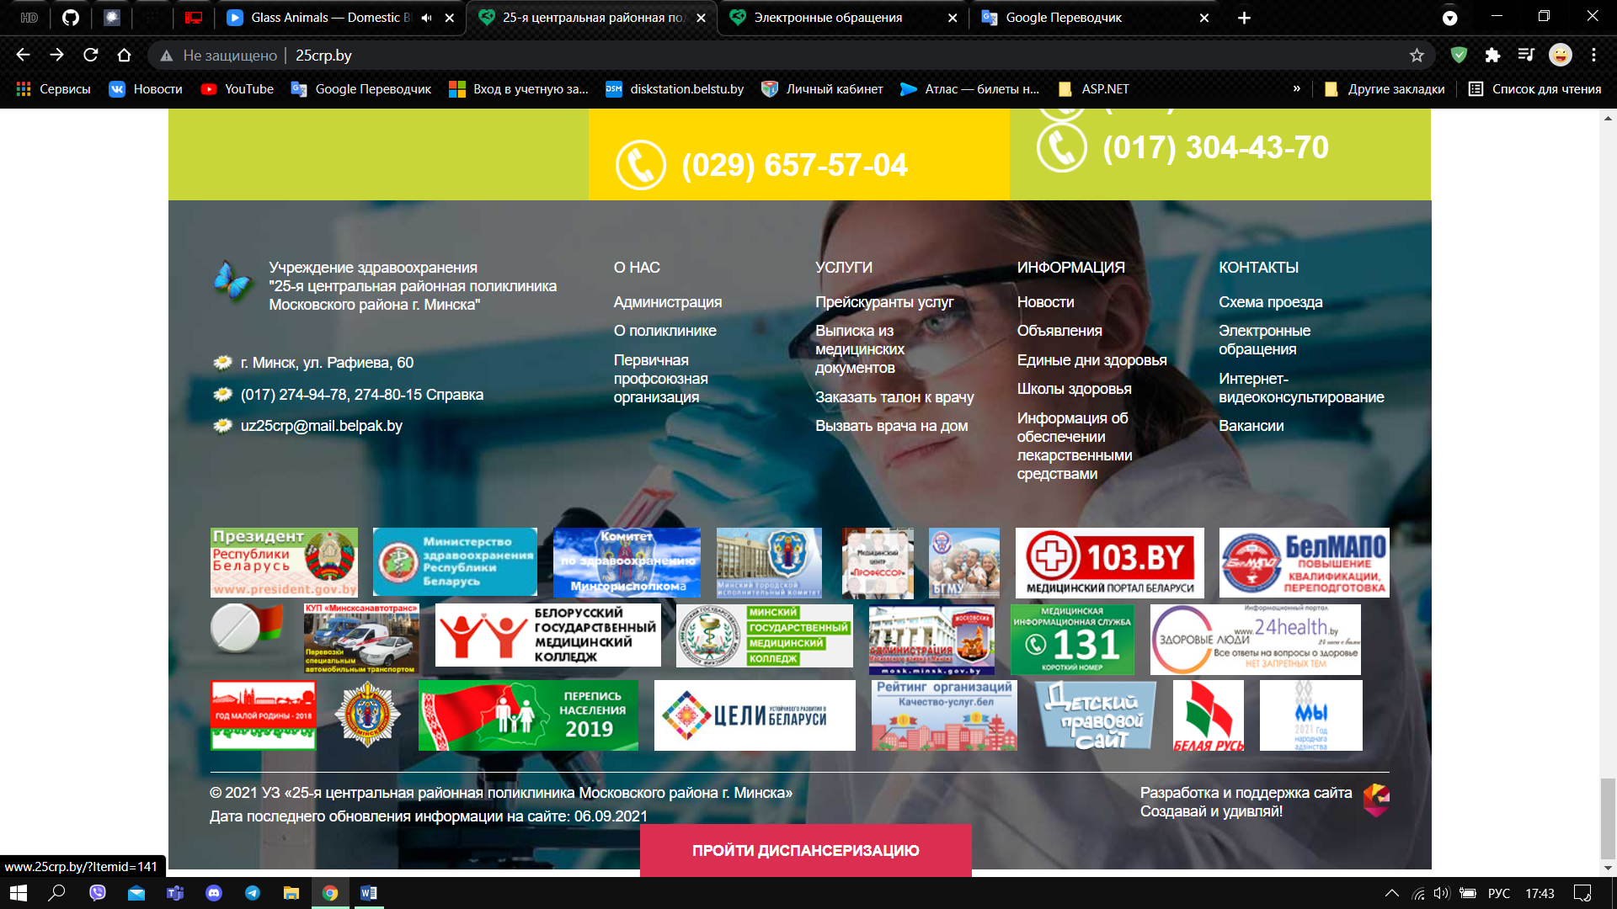

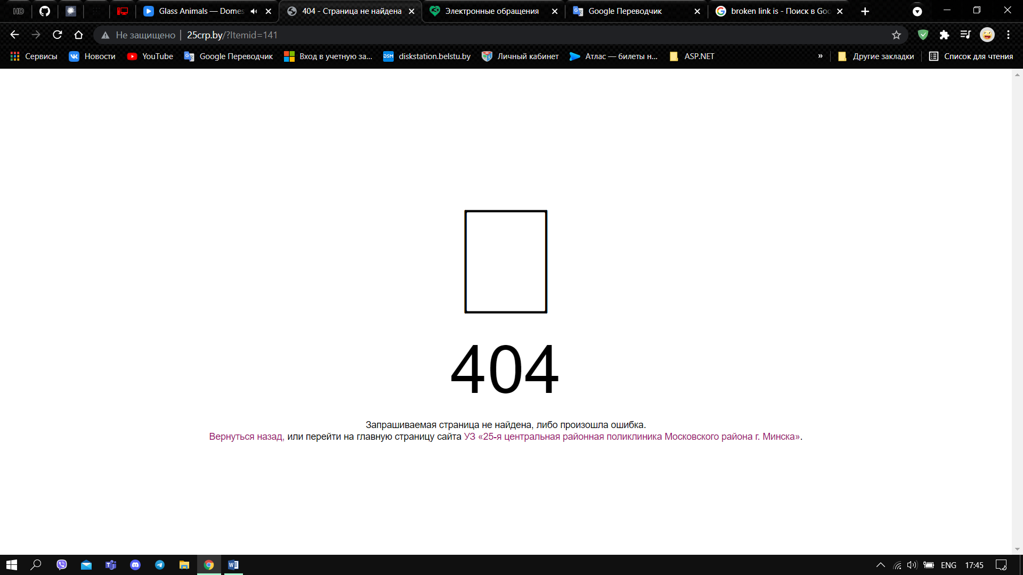

**Assignee:** Julia Aleksandrovna

**Steps to reproduce:**

1. Press the menu item in the footer named “Новости”

**Actual result:** Going to the 404-error page.

**Expected result:** Go to the news page

**Notes:**

**Report №8**

**Id:** 008

**Summary:** Broken link

**Environment:** Os: Windows 10/ Browser: Google Chrome

**Severity:** Major

**Priority:** High

**Screenshot:**

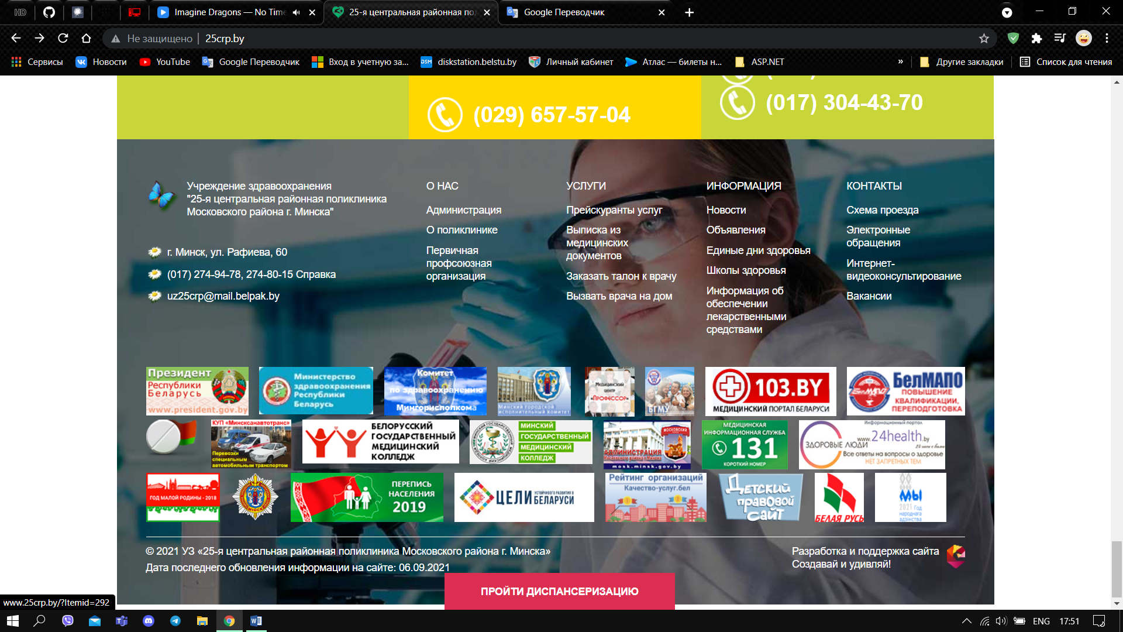

**Assignee:** Julia Aleksandrovna

**Steps to reproduce:**

1. Press the menu item in the footer named “Вызвать врача на дом”

**Actual result:** Going to the 404-error page.

**Expected result:** Go to the page

**Notes:**

**Report №9**

**Id:** 009

**Summary:** Site is unavailable

**Environment:** Os: Windows 10/ Browser: Google Chrome

**Severity:** Medium

**Priority:** High

**Screenshot:**

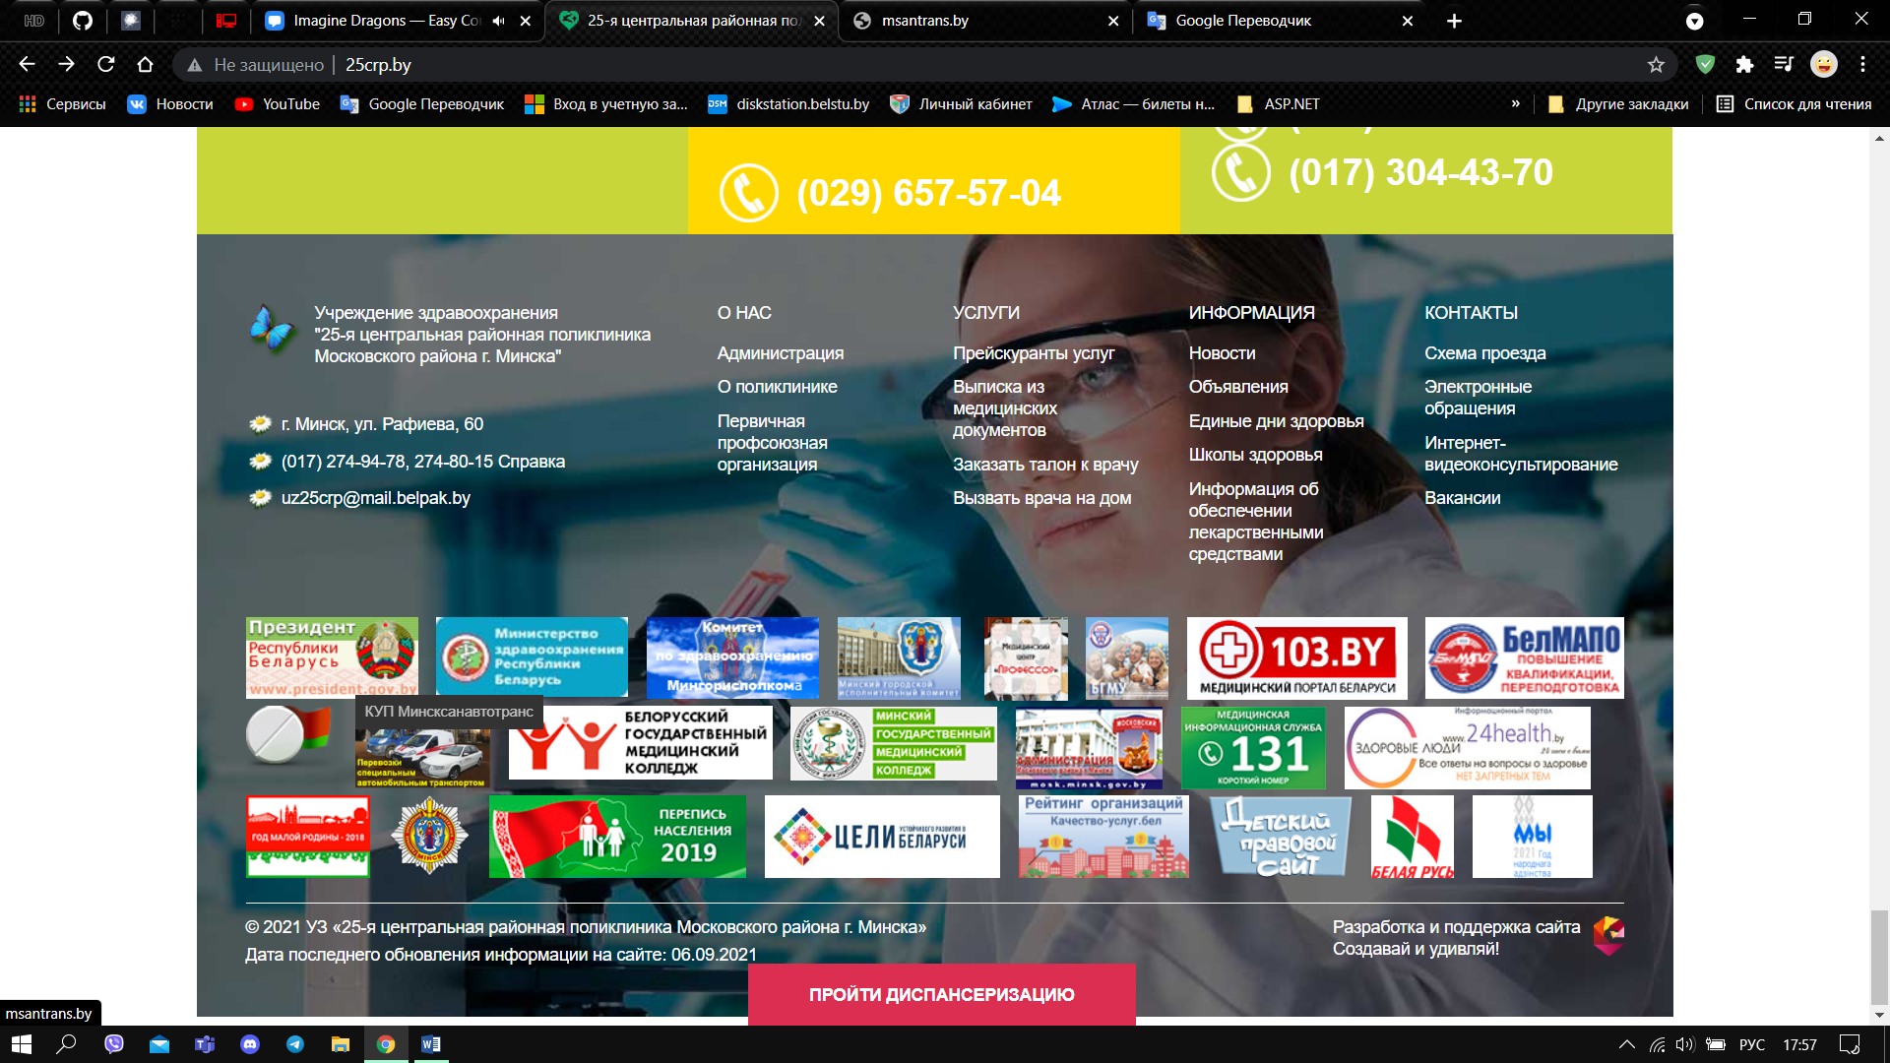

**Assignee:** Julia Aleksandrovna

**Steps to reproduce:**

1. Press the menu item in the footer named “Вызвать врача на дом”

**Actual result:** Going to the 404-error page.

**Expected result:** Going to the page

**Notes:**

**Report №10**

**Id:** 010

**Summary:** Broken link

**Environment:** Os: Windows 10/ Browser: Google Chrome

**Severity:** Major

**Priority:** High

**Screenshot:**

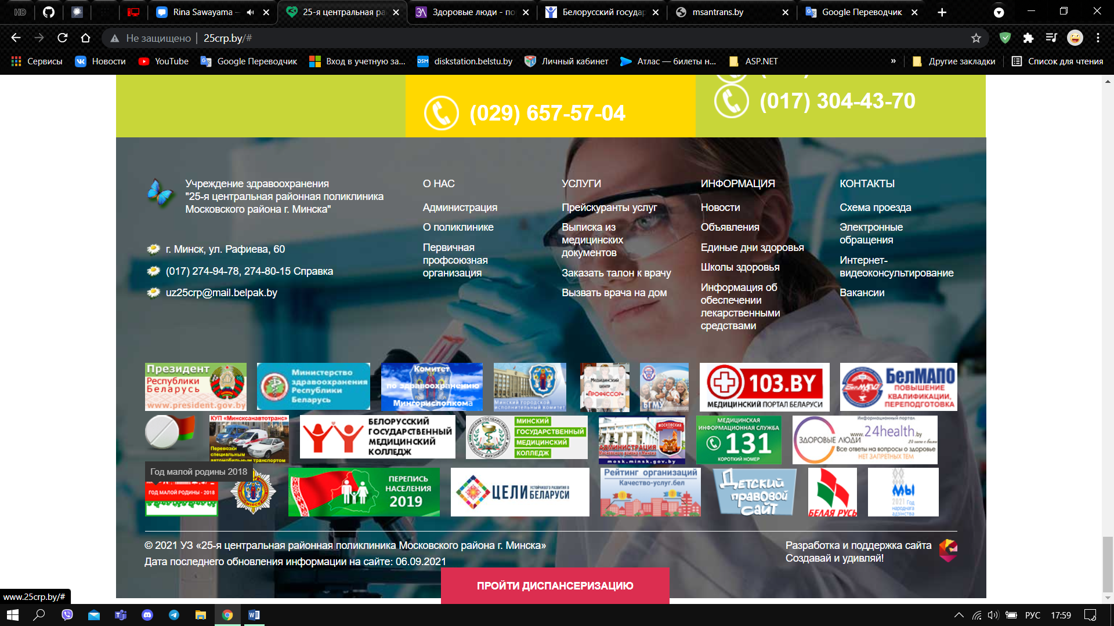

**Assignee:** Julia Aleksandrovna

**Steps to reproduce:**

1. Press the menu item in the footer section named «Год малой родины 2018»

**Actual result:** The page gets scrolled to its beginning itself

**Expected result:** Going to the page

**Notes:**

**Report №11**

**Id:** 011

**Summary:** Menu item gets out of the frame

**Environment:** Os: Windows 10/ Browser: Google Chrome

**Severity:** Low

**Priority:** Low

**Screenshot:**

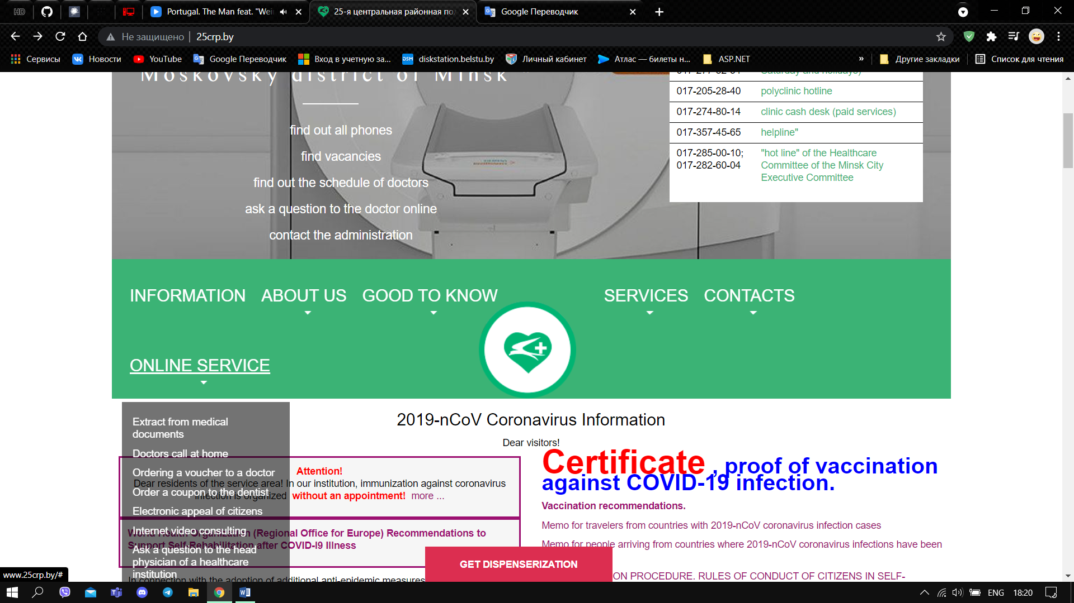

**Assignee:** Julia Aleksandrovna

**Steps to reproduce:**

1. Switch language to Belarusian

**Actual result:** The last item moves to another line

**Expected result:** The last item stays on the line

**Notes:**